

**Department of Computer Science**

This project has been satisfactorily demonstrated and is of suitable form.

This project report is acceptable in partial completion of the requirements for the Master of Science degree in Software Engineering.

|  |  |  |
| --- | --- | --- |
| BeAware – A Suspicious Activity Reporting and Alerting Application | | |
| Project Title | | |
| Akshay Ghorpade |
| Student Name |
| Ning Chen, Ph.D. |
| Advisor's Name |
|  | |
| Advisor's signature | Date |
|  |
| Reviewer's Name |
|  | |
| Reviewer's signature | Date |

**Abstract**

A traditional way followed till now to report and alert students regarding the suspicious activity happened on or around many college campuses is by contacting college police department and providing all the details. Which is followed by alerting other students by sending a campus-wide suspicious activity alert email. Since every single minute is important during this period it is important to have a process or system which do the reporting and alerting suspicious activity on a go. This paper will explain about the new idea to make this process instant and runtime. Now a days every person carries the most powerful gadget i.e. smartphone. Using a smartphone and a mobile application, students can report and alert each other regarding the suspicious activity by adding information which usually department of police request such as a description of the incident, when and where it took place etc. The new process also allows uploading a new photo taken with the smartphone's camera or already existing one in the gallery. This information will help college police department to track activities with the precise location of it. Even this information can lead to getting analysis report of which type of crime or suspicious activity is growing and which all locations it happens.

The suspicious activity reporting and alerting process focuses on what law enforcement agencies have been doing for years—gathering information regarding behaviors and incidents associated with crime and establishing a process to share information to detect and prevent criminal activity. This mobile application will improve the current tedious process of reporting and alerting students regarding the suspicious activity and reduce the chances of multiple occurrence of same incidence due to instant and robust reporting system.

**Table of Contents**

1. Introduction 4

2. **Background and Related Works** 6

3. Objectives 7

4. Approaches 8

5. Resources 13

6. Outcomes 14

7. Evaluation 15

8. Conclusion 16

9. References 17

1. **Introduction**

No one knows what goes on in your neighborhood better than you. You may see things or hear things that seem out of the ordinary and may indicate suspicious or illegal conduct. What if you can report an incident or suspicious activity on go using your mobile? Doesn’t it make the process to alert students instant and easier as compared to the current process adopted by the police department?

* 1. **Current Process**

The current process of reporting and alerting the student regarding the suspicious activity includes gathering, processing, reporting, analyzing, and sharing of suspicious activity. This process is done manually by campus police department to keep track and alert the student by writing an email with the incident details and sending it campus-wide. During this time what matters is that suspicious activity or incident should be reported as early as possible but current process of reporting a suspicious activity to the campus police department is done by contacting them via phone call or directly reporting the incident by going to them.

Another major problem is not many students have right away access to the email and they read it instantly. Thus, the current process is very tedious and time-consuming as each minute matters in this situation.

* 1. **Improved Process**

What if the same information pops out in your mobile notification and as soon as you click it you get the detailed information regarding the exact location, images, and a description on a mobile application. Doesn’t this new process will make you alert and cautious instantly so that you can avoid it happening with you?

Now using this application, a student can easily report the suspicious activity or crime incident to the campus police department right away without wasting time by providing a predefined set of information for a quick response from

Campus Police Department (CPD). Depending on the provided information and the severity of suspicious activity reported identified by CPD a campus-wide alert can be sent to all the student and staff with a single click. It improves the current tedious and time-consuming process to be instant and robust. it will help students to avoid such situation right away.

It also helps the new student joining the university to know the exact location of the incident on the map during the phase they are getting to know the campus.

This mobile application will help students and other people to report and be aware of the suspicious activity happening and notify people regarding the recent suspicious activity happened around them included with images, precise location, the category of activity and a description.

For several reasons, the public fears getting involved or may be uncertain

about how or where to report the activity. Many 9-1-1 Centers are already

fielding large numbers of non-emergency calls, reducing the manpower available for life-threatening, emergency requests. This Mobile application is designed to help overcome these challenges by empowering students to easily report and alert other students anonymously and in a form, that enables them to be quickly

evaluated at the local level.

1. **Background and Related Works**

Most of the existing application has a risk of fake user’s that may report a fake incident which a major issue. To eliminate this issue, we focus on the unique identification code i.e. CWID (Campus Wide Identification) and email code verification that will be sent on to the college email id provided by the user which unique and verified. Along with this administrator will be able to do an analysis on the reported incident including which type of activity from the category is increasing, mostly on which location or distance range it happens frequently etc. Which not only gives a chance of awareness as well as allows to avoid such activity in the future.

Many of the existing mobile application such as Suspicious Activity Reporting [1] deals with the reporting part but does not aware the other people instantly regarding it. It also overcomes the fact of this application being only available for a citizen living in West Virginia.

Another application which is quite a bit resembling is TipNow-AC Transit, it allows riders to be “an extra set of onboard eyes and ears helping to promote rider safety and system security.” Riders can choose between several icons, including “disruptive behavior,” “theft,” “suspicious activity,” “vandalism” and “unattended package,” to anonymously file reports [2]. The same issue with the system is other people are not made aware as soon as the report is submitted. Along with this, there has been an issue regarding the privacy of the user’s.

Not only just taking care of suspicious activity using a specific criterion of lost and found people can put the description of the item they lost with the images and description along with the radius area they think it was lost. So, if anyone can find it that person can contact the person who lost it instantly. It can be vice a verse if any person finds something and can add the details so as to find the right worthy owner of it.

This application reduces the process time to aware students about the suspicious activities or alerts with the precise location on the map. This application is not intended for emergency purposes. It is preferred to contact the police in first place during an emergency and then add it to the application so as to make another student cautious.

1. **Objectives**

* Improve and increase the speed of the current process to notify or report student about the suspicious activities by 80%
* Developing an application to track and notify suspicious activities occurred in or around the college campus to alert or aware students
* Ability to capture a photo from the app or use one that already exists on the

device

* Automatically find and use the location using geolocation or enter an address with 99.999% accuracy
* Remain anonymous if preferred, or include contact information
* The application should support multi-platform i.e. it should be available for Android as well as IOS devices
* The application renders the map properly during the runtime as well as during the application boot with 99.999% availability.
* The application should always keep track past suspicious activities
* Ability to track all previous activity for analysis by the administrator

1. **Approaches**

In this project, two stated goals were to first to produce a working GUI which will allow users to report the detailed information of the suspicious activity happened around them. The second goal was to allow those users to receive notification of the suspicious activity happening around them and able to access those activities to understand more about it. My approach to this problem is by first creating and establishing the Salesforce.com Dev Org and enabling all the required features such as location and map, creating featured tabs and application and security setting to access this application. So as to produce a working GUI for reporting suspicious activity for the user is by creating the required fields such as suspicious activity type, Description of the activity, when it happened, What happened, Date and Time of the incident and address of the location which is shown in the following image.

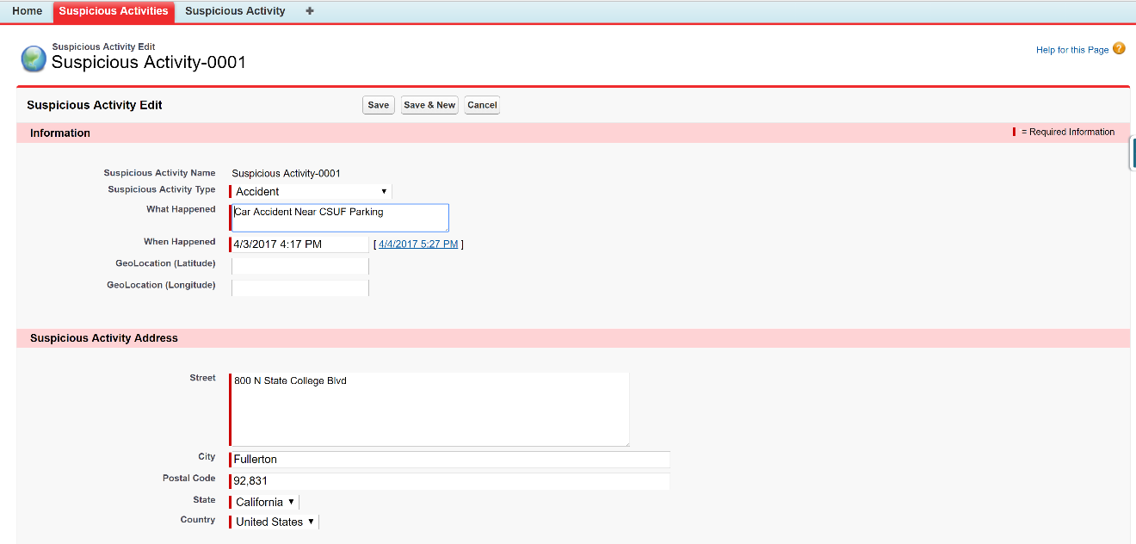

**Figure 1. Screenshot of function suspicious activity reporting GUI**

This GUI illustrates the suspicious activity reporting function with an option to Save, Save and New and Cancel. It also demonstrates the validation handling for required fields. The first requirement states that it must allow the user to add images from their own system to make reporting more informative which is demonstrated in Figure 2.

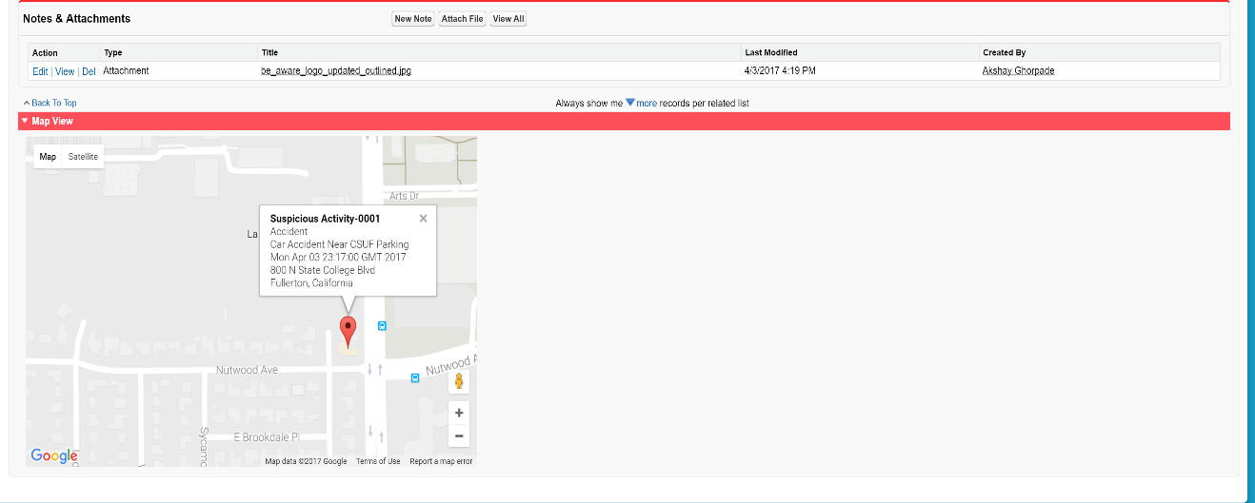

**Figure 2. Screenshot of function to display added suspicious activity on the map with details**

As part of the requirement, it generates a map with a marker pointing at the specified address of the suspicious activity and its details. I have used the Google Maps API for generating a map and creating a marker. I am passing the address entered by the user to the Google API to retrieve the location and add a marker at that location with the other details such as Suspicious Activity Name, Type, What Happened and When Happened as shown in figure 3.

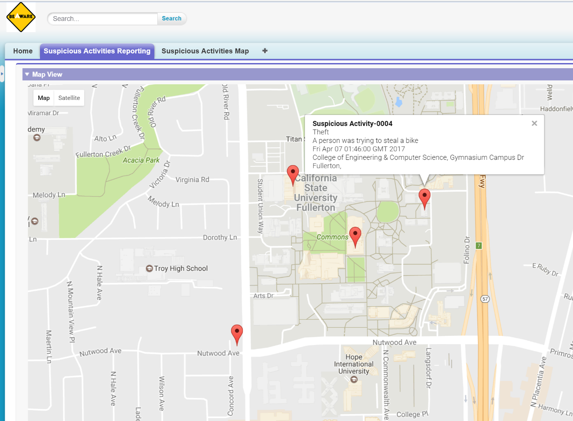

**Figure 3. Screenshot of a map showing all the suspicious activity**

As part of the retrieving and storing data, I am using the Salesforce.com provided language Salesforce Object Query Language (SOQL). Salesforce Object Query Language (SOQL) to search your organization's Salesforce data for specific information. SOQL is like the SELECT statement in the widely used Structured Query Language (SQL) but is designed specifically for Salesforce data.

This first stab at a working GUI has already provided some insight into whether this idea is workable. On the positive side, Salesforce.com provides plenty of the basic controls necessary to set up a basic of BeAware application. Laying out the controls needed to achieve the desired look of the application was relatively quick and straightforward. It is easy to see that the functionality, features, and libraries provided by Salesforce.com will be sufficient to produce a basic GUI.

As a part of the second requirement, this application includes tab and Visualforce page which will gather all the stored information from the user and will display it on single map window. It used Apex as backend manipulation with a wrapper class to create a list of data and retrieve it at runtime and provide it to the Visualforce page.

A few unresolved points remain after my initial design work though. First, Salesforce.com doesn’t allow the user to self-register to the application. Users must be created within the system and allowing them access to the application. For this issue, I am moreover going to create an external site which will allow the option of sign in and self-registration to external users by capturing required information and creating a user in the Salesforce.com by integrating two systems.

Another approach for the same problem is by using the feature of Salesforce.com to create communities and enable the option of self-signing in and registration to the application as shown in the below Figure 3. It reduces the cost of hosting external registration site and provides the control on the security of the amount of access user can have over the application.

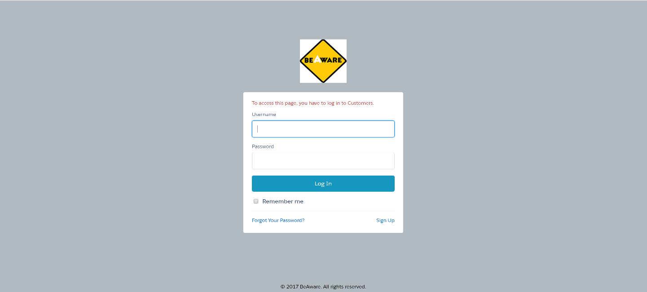

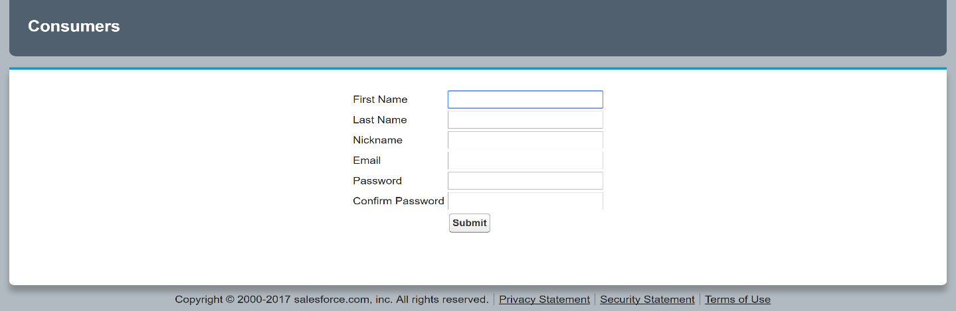

**Figure 4. Showing the community singing and registration page**

This application uses the concept of Single Page Application so as to provide all the required functionality on a single page by using the new Salesforce.com feature called as Salesforce Lightning. It enables the user to access the trending things discussion happening on a reported suspicious activity using functionality called as Salesforce.com Chatter which enables the user to write a post or comment using the hashtag feature. Along with this, it allows to create a poll and raise a question regarding suspicious activities on a go from a single page.

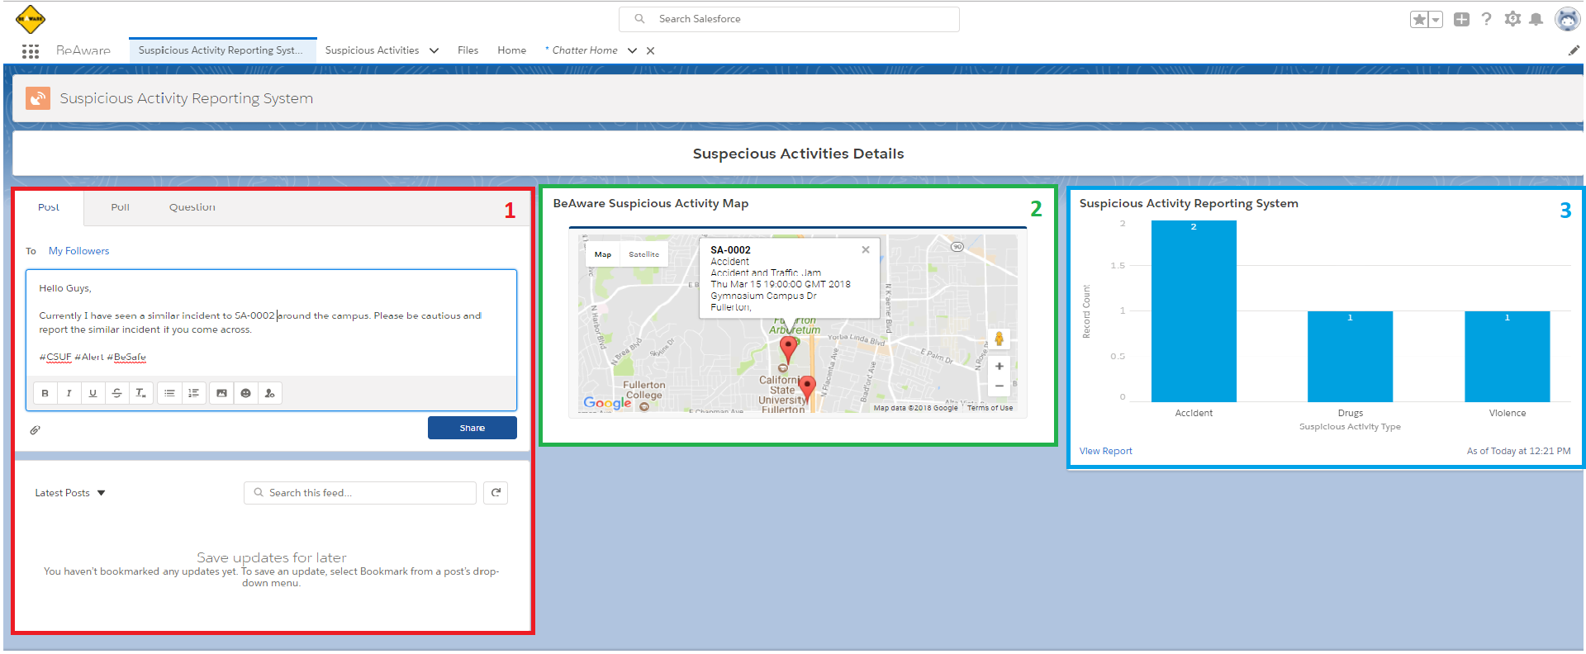

**Figure 5. Suspicious Activity Reporting System’s Single Page Application**

1. **a. Chatter Post**: Enables to write a post or comment on a particular incident and is visible to all the users i.e. students and staff.

**b.** **Poll:** Allows the user to create a poll for gathering responses what user things on a particular topic or incident. Example – College Police Department asking for suggestions to improve the response to an activity.

**c.** **Questions:** User can post a question regarding particular or in general suspicious activity so that they can get answers regarding it from the officials.

**2. Suspicious Activities Map:** Provides location-based service and details of the reported activities and incidents.

**3. Dashboard and Reporting Component:** It provides analytics on the reported suspicious activity such as bar chart to provide detail which activity has been increasing etc.

1. **Resources**

**Hardware**

* DELL INSPIRON (Intel i7 3.4 GHz, 8 GB of RAM) running on Windows 10 operating system
* 20 MB of disk space minimum (250 MB recommended depending on the size of the briefcase)
* Internet access with minimum speed of 3.0 Megabits per second

**Software**

* The current or immediately previous version of Internet Explorer, Safari, Chrome, Firefox, or Microsoft Edge
* Salesforce.com require the Adobe Flash Player plugin. In your browser, enable or install Flash version 9.0.115 or later
* Access to Salesforce.com Dev Org for development and running the application
* Force.com access for development and testing which include languages such as Visualforce, Apex, and SOQL
* Data Loader software for performing DML on the records
* Salesforce.com Android and iPhone SDK for native application development

**Mobile Devices**

* A smartphone with any operating system such as Android, iOS, and Windows
* Salesforce must have Salesforce App installed

1. **Outcomes**

* Increased Report Accuracy and Duration by 60% - The adage, “a picture is worth a thousand words” has never ringed truer. The ability to submit a photo and information instantly is the best measure to ensure accuracy that law enforcement could ask for. [4]
* The application support multi-platform i.e. it should run on Android and IOS devices.
* Smooth rendering of the application and map with a precise accuracy of 99.999% to locate a suspicious activity on the map.
* This application provides 99.999% availability
* This application will help students to be aware of the suspicious activities and become cautious to avoid it happening with them.
* Reduces the process time by 80% to aware students about the suspicious activities or alert with the precise location on the map.
* At the later point as the basic requirement is achieve a module of lost and found feature will be added to the main application along with the object recognition system using AI.

1. **Evaluation**

This application will help to aware and notify students about the suspicious activity happen in or around the campus using an application on mobile device. It reduces the time consumed during the process of the calling or reporting incident to the campus police department.

It is aimed to aware and makes student cautious about the suspicious activity or the alert them instantly. It is an application by and for the students.

It will help to reduce the number of victims of the suspicious activities and help student instantly know what and where about the situation around them.

This application can help to get a detailed report of the activities along with all the proof such as image, location and a brief description of similar activities so that those areas can be surveyed by the police department to prevent it happening again.

The success of this application can only be noted by the number of reduced report of the same type of suspicious activities happening again and action taken care by the college police department to avoid it.

It requires a consideration that there won’t be any fake report to increase the effect and benefit of the project.

To increase the success this application should be 99.99% available to the user without any downtime. Since the intention of this project is crucial to avoid and report crucial suspicious activities it must be available for the user’s 24x7.

1. **Conclusion**

The results of this project add new insights into the how current Suspicious Activity reporting and alerting process can be improved so as to make a campus safer for students and staff members. It emphasizes on reporting the Suspicious Activity to the Campus Police Department rather than neglecting it due to current tedious and time-consuming process for safer and better college campus for everyone. It eliminates the barriers of why individuals do or do not report suspicious activity, as well as the technology and resources that can be used to help encourage suspicious activity reporting. With this information, law enforcement and community partners can better develop and adapt strategies to improve community outreach and education efforts that enhance the public’s awareness and reporting of suspicious activity. This application helps in reporting suspicious activity and helps law enforcement agencies and community partners to understand, navigate, and use the many resources available to help build and sustain local initiatives. Community members have long been one of law enforcement’s best sources of information on what is out of place or suspicious in their communities. This application is expected to reduce the number of incidents and provide a safe and secure campus environment.

**Reference**

[1] NIC Inc. - November 25, 2014 - Everyone. (2014, November 25). Suspicious Activity Reporting - Android Apps on Google Play. Retrieved March 15, 2017, from https://play.google.com/store/apps/details?id=susp.ac&hl=en

[2] AC Transit Launches New Safety App: TipNow. (n.d.). Retrieved March 15, 2017, from http://www.actransit.org/tipnow/

[3] Suspicious activity report. (2017, March 14). Retrieved March 15, 2017, from <https://en.wikipedia.org/wiki/Suspicious_activity_report>

[4] 2013 NASCIO Recognition Award Application. (n.d.). Retrieved March 15, 2017

[5] THE U.S. COAST GUARD MOBILE APP. (n.d.). Retrieved March 15, 2017, from <https://www.uscg.mil/mobile/>

[6] Virginia Fusion Center. (n.d.). Retrieved March 15, 2017, from <http://www.vsp.state.va.us/FusionCenter/mobileApp.shtm>